Implementation Guide
Longitudinal ASCVD Risk Assessment Tool for Shared Decision Making
Prepared for:
Agency for Healthcare Research and Quality
U.S. Department of Health and Human Services
5600 Fishers Lane
Rockville, MD 20857
www.ahrq.gov
Contract No. HHSA290201600001U
Prepared by:
Pace Ricciardelli, MS
Sharon Sebastian, MS, RN-BC, PMP, CPHIMS
Jonathan Teich, MD, PhD
MITRE Corporation
AHRQ Publication No. 18-0007-3-EF
October 2017
Disclaimer
The findings and conclusions in this document are those of the author(s), who are responsible for its content, and do not necessarily represent the views of AHRQ. No statement in this report should be construed as an official position of AHRQ or of the U.S. Department of Health and Human Services.

Disclaimer of Conflict of Interest
None of the investigators has any affiliations or financial involvement that conflicts with the material presented in this report.

Funding Statement
This project was funded under contract/grant number HHSA290201600001U from the Agency for Healthcare Research and Quality (AHRQ), U.S. Department of Health and Human Services. The opinions expressed in this document are those of the authors and do not reflect the official position of AHRQ or the U.S. Department of Health and Human Services.

Public Domain Notice
This document is in the public domain and may be used and reprinted without special permission. Citation of the source is appreciated.

Suggested Citation
Suggested citation: Ricciardelli P, Sebastian S, Teich, J. Implementation Guide: Longitudinal ASCVD Risk Assessment Tool for Shared Decision Making. Prepared under Contract No. HHSA290201600001U. AHRQ Publication No. 18-0007-3-EF. Rockville, MD: Agency for Healthcare Research and Quality; October 2017.

Contents
Introduction 1
Background 1
Audience, Purpose, and Scope of this IG 1
Implementing and Using This Artifact 2
Description and Purpose of the Artifact 2
Summary of the Clinical Statement 2
Primary Use Cases 3
Additional Use Cases 5
Recommendations and Suggested Actions 5
Guideline Interpretation and Clinical Decisions 6
Artifact Development Plan 7
Form a Cross-Functional Team 7
Identify Appropriate Value Sets and Codes 8
Review Existing CQL Libraries and Develop CQL 8
Review and Test Developed CQL 9
Automated Execution of Test Cases 9
Manual Review of the Artifact 10
Expected Timeline 10
Appendix A: Decision Log a
Artifact Recommendation Statement a
Decision Logs b
Appendix B: Acronyms e
Reference List f

Figures
Figure 1: ASCVD Risk Calculator Example 4
Figure 2: CDS Artifact Maturity Process 7

Tables
Table 1: Definitions of Shiffman’s Steps a
Table 2: Decisions Based on “Atomized” Components of the Recommendation Statement b
Table 3: Additional Decisions c

Introduction
The Agency for Healthcare Research and Quality (AHRQ) has elected to sponsor a project that will help to generate a systematic and replicable process for transforming patient-centered outcomes research (PCOR) findings into shareable and standards-based clinical decision support (CDS) artifacts. A CDS artifact is the template for defining how decision support is provided for a given clinical situation, often including triggers, logic, operations, recommendations and actions, and supporting evidence. A main outcome of this project will be an online Repository for storing and accessing CDS artifacts. It is hoped that this publicly available Repository will promote the usage of CDS in everyday clinical settings, and that it will serve as the linchpin for connecting high-quality CDS to the U.S. healthcare community.

Background
The purpose of the CDS Connect Repository is to store and provide access to CDS artifacts, including text and computable versions of the decision logic; suggested trigger events; text recommendations and suggested actions; and metadata, including original evidence links, decisions made in creating the artifact, sponsoring clinical organizations, and keywords. It is envisioned that it may at some point become a home for user feedback and experience data as well. The CDS Connect Repository enables users to search easily for desired artifacts, to explore their contents, and to facilitate their transfer into and use in locally used electronic health records (EHRs), CDS services, and other technology tools.
The concept of a CDS Repository was introduced in the HHS-sponsored Roadmap for National Action on Clinical Decision Support¹ (2006). Subsequent efforts, including the CDS Consortium (2008), Advancing CDS contract (2010), National Quality Forum CDS Expert Panel (2011), Health eDecisions (2012), and the National Academy of Medicine Optimizing Strategies for CDS project, among others, have advanced the concept of shared CDS. The CDS Connect project advances the goal of shareable CDS by establishing an actual public repository of CDS that can be contributed to and consumed by many stakeholders.
With further development, additional features are projected for the Repository, including—
- making several types of CDS available (such as alerts, order sets, intelligent data presentations, relevant evidence and knowledge; tools for shared decision-making with patients).
- providing several options for displaying and using repository information.
- allowing users to subscribe to artifact updates.
- allowing users to review and rate artifacts in the Repository and provide usage data.

These features will enhance the quality, validity, and value of the Repository, and create a climate of mutual ownership of artifacts across the CDS and EHR user community. The provenance and sponsorship of any artifact is visible and searchable in the Repository.

Audience, Purpose, and Scope of this Implementation Guide
This document is intended to provide information about the generation, implementation, and routine operation of the Longitudinal ASCVD Risk Assessment Tool for Shared Decision Making artifact. Various audiences may find this information helpful, including:
- Clinicians and Quality Leaders at healthcare organizations and practices who wish to implement, test, and execute CDS related to this topic in their EHRs and other health information tools.
- Patients and Family Caregivers who wish to have active CDS to help them direct self-care activities or who are interested in the process of CDS development and implementation for shared decision-making more generally.
- CDS Developers and Informaticists who may have suggestions, additions, or seek to add CDS artifacts on similar topics, or who want to make use of well-developed structured logic and Clinical Quality Language (CQL) in their own work.
- Organizations or Individuals interested in developing their own CDS artifacts, who may find this document helpful as a guideline for the process by which clinical guidelines are translated into mature CQL artifacts.

Implementing and Using This Artifact

Description and Purpose of the Artifact
This artifact extends the artifact “Longitudinal ASCVD Tool for Baseline 10-Year ASCVD Risk.” This family of artifacts provides the ability to calculate and display the base 10-Year ASCVD risk score for an individual to help when considering initiating or optimizing therapy for primary prevention of ASCVD. It utilizes the 2013 ACC/AHA pooled cohort equation to calculate the risk for developing a first-time “hard” ASCVD event, defined as: nonfatal myocardial infarction (MI), coronary heart disease (CHD) death, nonfatal stroke, or fatal stroke.
This artifact addresses the second of 3 clinical scenarios where the Longitudinal ASCVD Risk Assessment Tool might be used:
- Calculation of a baseline 10-Year ASCVD risk assessment score, prior to initiation of any new therapies to address this risk.
- Prospective estimations of ASCVD risk in support of shared decision making while considering the benefits of therapies, alone or in combination.
- Calculation of updated risk after preventive therapies have been initiated.

Summary of the Clinical Statement
The basis of the risk calculator comes from the 2017 ACC/AHA Special Report². The Million Hearts Longitudinal ASCVD Risk Assessment Tool is an instrument calculated using the ACC/AHA 2013 Pooled Cohort Equations (PCE), providing sex- and race-specific 10-year estimates of ASCVD risk. They are intended for use in patients 40-79 years of age who have not had ASCVD. The risk calculations have been validated in a broadly representative sample of U.S. whites and African Americans.
The Baseline calculation allow for estimate of initial baseline risk based on key parameters, including age, gender, race, total and HDL cholesterol, systolic blood pressure, smoking within the past year, presence of diabetes, and treatment for high blood pressure.
The Shared Decision Making calculations show the change in estimated risk that would be associated with institution of one or more preventive interventions, including smoking cessation, aspirin therapy, blood pressure control, and statin therapy, if these have not already been started.
The Updated calculation compares the original Baseline risk with the Updated risk based on interventions that have been instituted and their impact on measures including LDL cholesterol and systolic blood pressure.
Additional reference information can be found in the Textual Metadata section of the artifact in the CDS Connect Repository.

Primary Use Cases
The three ASCVD risk calculations in this family are primarily for use by providers and patients doing assessment and treatment planning in a primary care or cardiology practice setting. The artifact is suitable for producing an intelligent data display. An implementation of the CDS artifact can produce (1) a “calculator” view of the parameters listed above, with opportunity for the user to correct or adjust any values, and (2) the calculated risk score, displayed on screen and potentially available for other CDS artifacts, such as cholesterol-lowering CDS algorithms that make use of the risk score as part of their calculation.
A typical calculator view might look like Figure 1, where the score is prominently displayed while the supporting parameters, whether filled in automatically from EHR data or adjusted manually, appear below. Compared to the Baseline risk assessment calculator display, the Shared Decision Making display here shows not only the risk based on current parameters, but also the modification in risk expected if statins, hypertension treatment, aspirin therapy, and/or smoking cessation were to be initiated. By turning on and off the various checkboxes for these interventions, the provider and patient can work together (or in alternative use cases, the patient can work alone) to understand how much each intervention and each combination of interventions can reduce their risk.

Figure 1: ASCVD Risk Calculator Example
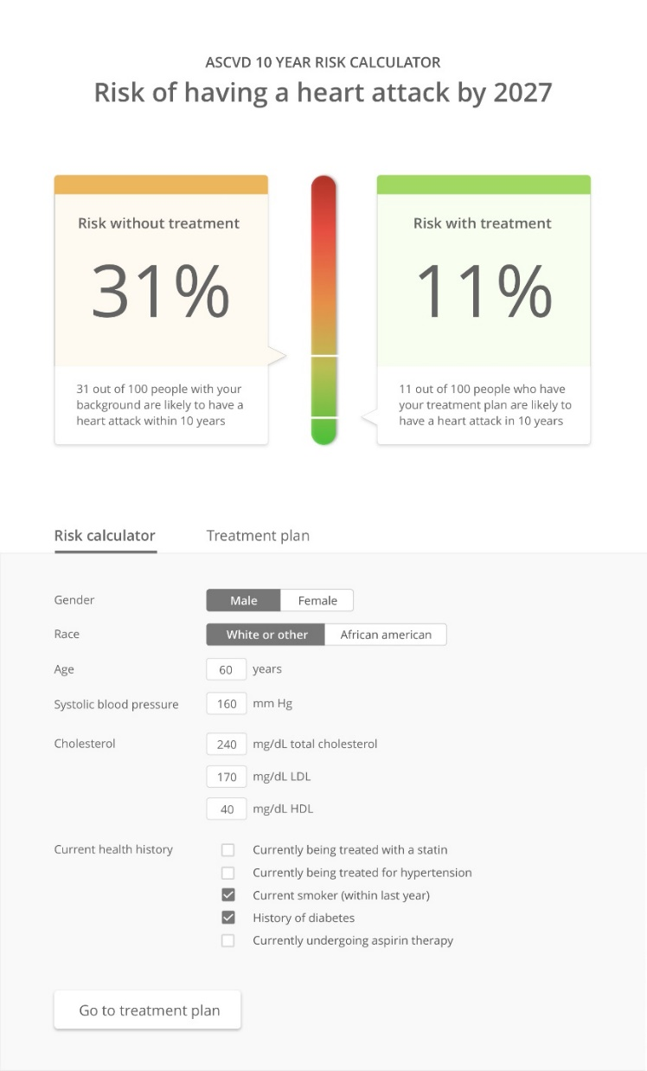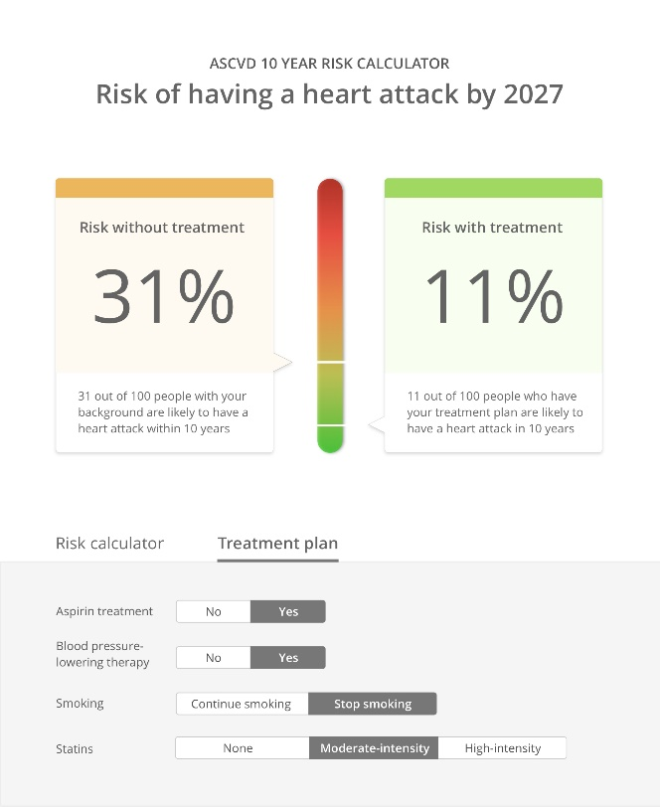

The shared decision making calculator interaction is typically performed after a baseline risk calculation has been done, although it can be done at any time.
Typical scenarios include:
- Upon request, typically as part of a patient encounter
Ms. Bravo, a 55-year-old African-American nondiabetic patient with hypertension, comes in for a regular annual checkup. She has not had an ASCVD risk calculation done previously. Her clinical practitioner requests the risk calculator to execute. Using data from Ms. Bravo’s EHR, the algorithm executes and a calculator view is displayed on screen, showing all relevant parameters and her calculated risk score of 31%. In some implementations, this view also allows manual adjustment of parameters that might not have been fully or correctly captured, such as smoking status. Ms. Bravo and her clinician can then manipulate the boxes in the calculator for statins, aspirin, blood pressure control, and smoking cessation, and see how her risk would change. Through this exercise, they can begin to decide together which interventions to consider, while weighing treatment side effects and lifestyle impact.
- As part of another CDS artifact run during a visit
A different CDS artifact is being run against Mr. Delta’s data to consider whether a statin recommendation is indicated. If that artifact produces a positive recommendation for statin use, Mr. Delta and Dr. Charlie could ask to see this risk calculator, so they can see more clearly the impact of using statins on his overall cardiac risk.
Note that some of the shared decision making interventions will not affect the risk score if they are already in place (i.e., if the patient is already a nonsmoker; already on statins, aspirin, or blood pressure treatment). In this case, the calculator should have the indicated boxes checked (as in the visual example above) and warn if the user tries to modify these parameters.

Additional Use Cases
Additional use cases utilize the decision logic and recommendations, but may require adjustments for a different workflow, type of user, or mode of operation. Additional use cases for this artifact could include:
- Patient self-care/family caregivers as part of self-assessment or health maintenance:
Mr. Delta runs an overall general health self-assessment or cardiac risk self-screen, as part of a self-care program. The risk score display is presented as part of the assessment, showing his current risk. In addition, he can use the shared decision making features to understand for himself how various recommended interventions would impact his overall cardiac risk.

Recommendations and Suggested Actions
The recommendations, warnings, and interventions provided by this CDS artifact can be found in detail under “Potential Intervention(s) and Action(s)” in the Semi-Structured Representation section of the artifact. In summary, they include a list pertinent to all ASCVD risk calculator artifacts and additional items specific to shared decision-making.
Items pertinent to all risk calculator artifacts:
- Notify the user if the patient is excluded, because of age less than 40 or greater than 79 or a history of ASCVD.
- Notify the user that, even though the algorithm is executing, it may not be fully valid or may need to be adjusted for patients with familial hypercholesterolemia, or patients who are not white or African-American.
- Display the ASCVD risk calculation as a calculator view or data view.
- Populate the calculator with known parameters from EHR data, while indicating which parameters could not be obtained, if any.
- Allow the user to modify parameters in the calculator.
- Notify the user that certain parameters (including total cholesterol, HDL cholesterol, and systolic blood pressure) were out of the validated range and have been adjusted to the nearest in-range value.
- Display the ASCVD risk score as derived from the collected and entered parameters.
- Document the ASCVD risk score in the patient’s record. This is not a standard EHR data element, and currently each implementation must identify where this is stored in the record for applications that make use of the score and for documenting that a score was performed.
Items specific to shared decision making:
- Allow the user to manipulate the controls pertinent to possible interventions.
- Display the adjusted risk if the selected interventions were done.
- Document any interventions that were decided upon by the patient with the clinician (or without the clinician, in the case of patient self-use of the artifact).
- Provide the patient with information resources that outline benefits, risks, effects, and evidence behind each of the possible selected interventions, to further aid decision making.

Guideline Interpretation and Clinical Decisions
It is often necessary to interpret or adjust clinical guidelines to make them suitable for computation. In addition, the CDS Connect Cholesterol Management Work Group provided insight to clarify exclusions, inclusions, and parameters that were specified in the recommendation statement, outlined in the source content, or deemed to be otherwise important to the proper application of the guideline as CDS. Decisions outlined in Appendix A explain, in detail, how source content text was interpreted and representations were defined during artifact creation.
Some of the more meaningful interpretations and decisions found in Appendix A include:
- Maintain a modular approach to CDS creation by separating the calculation of ASCVD risk (in this artifact) from statin therapy recommendations presented in other artifacts. These artifacts will be tagged as being related to each other, but allow the user options in what is implemented.
- Indicate that non-white, non-African-American patients may need score adjustment, but still provide the risk calculation as specified.
- Indicate that patients with familial hypercholesterolemia may have increased risk that is not well depicted with this calculation, but show the calculation anyway with this caveat.
- Replace values for systolic hypertension, HDL cholesterol, and total cholesterol that are outside the validated ranges for this algorithm with the nearest in-range value and proceed with the calculation, but notify the user that this adjustment was made.
- Exclude patients who already have ASCVD in the expression logic, as their risk for having ASCVD in the next 10 years is already 100%.
- Define “treatment for hypertension” as the existence of an active antihypertensive medication in the patient’s file and a diagnosis of hypertension, since several antihypertensive medications are used for other indications.
- Allow local adjustment of lookback period for previous ASCVD scores within the 4- to 6-year range specified in the source recommendation statement (i.e., 4 years, 5 years, or 6 years).

Artifact Development Plan
Boxwala et al.³ developed a multi-layered knowledge representation framework for structuring guideline recommendations as they are transformed into CDS artifacts. The framework defines four “layers” of representation:
- Narrative text created by a guideline or CQM developer (e.g., the recommendation statement described as a sentence).
- Semi-structured text that describes the recommendations for implementation as CDS, often created by clinical subject matter experts. It serves as a common understanding of the clinical intent as the artifact is translated in to a fully structured format by software engineers.
- Structured code that is interpretable by a computer and includes data elements, value sets, and coded logic.
- Executable code that is interpretable by a CDS system at a local level. This code will vary for each site.
This artifact is a semi-structured representation of medical knowledge that contains Boolean logic statements.
Figure 2: CDS Artifact Maturity Process
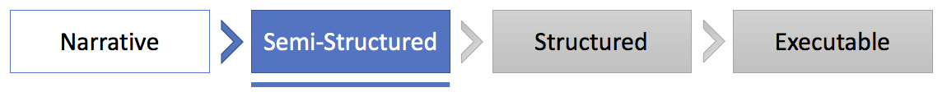
To continue the maturation of this artifact to the structured stage, several steps need to be taken:

Form a Cross-Functional Team
Translating this semi-structured representation of medical knowledge into a structured representation using CQL code requires a combination of skills that are not commonly possessed by a single individual:
- A clinical background that includes working knowledge of the underlying clinical guideline and its application in medical practice.
- Familiarity with clinical code sets (e.g., ICD-10, SNOMED-CT, RxNorm, etc.) and their implementation in health information technology products.
- The ability (or willingness to learn how) to develop code in several languages, at a minimum CQL and one other language, to be used for the execution of test scripts.
Each of these skillsets will be necessary at various points in the CQL development process, with some tasks being done synchronously and others done asynchronously. The team should plan to meet at least weekly to evaluate status and collaborate on joint tasks.

Identify Appropriate Value Sets and Codes
Generation of a structured CDS artifact begins with the identification of existing value sets or codes that can be used to represent the clinical concepts in the semi-structured artifact. For example, if a semi-structured artifact mentions “Diabetes” as part of its logic, there are many SNOMED-CT, ICD-9, and ICD-10 codes that could be used to represent a patient with an active condition of “Diabetes” in an EHR. Implementers should review the Value Set Authority Center (VSAC) to determine whether existing value sets are sufficient to express each clinical concept in an artifact. VSAC provides a website and an application programming interface (API) with access to all official versions of vocabulary value sets contained in Centers for Medicare & Medicaid Services (CMS) electronic Clinical Quality Measures (eCQMs). If a clinical concept in the semi-structured artifact cannot be expressed using existing value sets, implementers may create their own value sets through VSAC (e.g., a value set for “Familial Hypercholesterolemia” was created as part of MITRE’s work for another artifact posted on the CDS Connect Repository).
Implementers should be forewarned—reviews of existing value sets are primarily manual processes, and comparison of content across value sets is difficult:
- Many value sets are missing purpose statements, or the existing purpose statements are vague and don’t include any additional meaning beyond the value set title. Be prepared to inspect the value sets to determine their fitness for purpose.
- There are many competing value sets for what appear to be the same clinical concepts in VSAC. Investigate the alternatives and decide on value set usage based on the context of the clinical guideline. While part of the reason for using standard value sets is that they are maintained and keep up with changing usage patterns, it would also be prudent to validate the chosen value set against codes that are in use at the implementation site(s).
- The VSAC does not show whether a value set is actively maintained or deprecated. For example, a value set last updated in 2014 may or may not be current. To infer whether a value set is current, one must determine if the value set is used in any of the latest eCQMs, and if not, why:
  - The eCQM itself may have been removed/retired. It is unclear what happens to the value sets in this scenario.
  - The value set has been harmonized or replaced by a similar value set in the eCQM. This information is noted in the eCQM release notes (if one can find the version where the change was made) but is not carried over to the VSAC.

Review Existing CQL Libraries and Develop CQL
In developing CQL code, implementers should follow the lead of the semi-structured artifact. Begin by establishing the inclusion and exclusion criteria for the artifact in CQL. When the population of patients is established, model the subpopulations that will contribute to various recommendations laid out in the semi-structured artifact. Use those subpopulations to generate recommendations. Finally, build any clinically relevant warnings or error messages into the CQL code. Generally, most errors and warnings are related to missing or outdated data in a patient’s medical record.
Whenever possible, developers should reuse existing CQL libraries or code snippets. Aside from the existing artifacts in the CDS Connect Repository, developers can review the following resources for guidance on developing CQL:
- CQL STU Release 1 at HL7
- CQL Tools on GitHub
- CQL Formatting and Usage Wiki
- CQL Online
- CQL Q&As on the eCQI Resource Center
CQL code from other artifacts have been developed to enact specific clinical guidelines, but portions of that code may be helpful for translation of unrelated future into CQL:
- The CDS_Connect_Commons_for_FHIRv102, FHIRHelpers, and CDS_Connect_Conversions libraries included in existing CQL artifacts define commonly used functions in CQL files and are not specific to any clinical guideline. They can be used with any other CQL file that could benefit from those functions.
- Selected code blocks from existing artifacts could be copied and reused in other CQL files. For example, some have expressed interest in the definition of pregnancy (based on the existence of either a condition code or observation code).
Implementers may face challenges due to the current lack of tooling available for development and testing of CQL code. More mature languages tend to have multiple tools associated with them, but CQL is an emerging language. MITRE is currently developing a CDS Authoring Tool that allows users unfamiliar with CQL syntax and structure to create CQL with a graphical user interface. At the time of publication, this tool has not been released to the public.

Review and Test Developed CQL
After CQL representations of artifacts have been developed, they should be thoroughly reviewed for technical and clinical accuracy. The CQL logic should be both clinically meaningful and minimally prescriptive to allow flexibility in implementation by multiple organizations. Developers should refactor logic that is not specific to the artifact (e.g., unit conversions) into included libraries. Test cases should be developed and executed against the CQL, with special attention paid to logic coverage, edge cases, negative cases, and clinical relevance.
Review and testing of a CQL artifact should be composed of (at a minimum) two components: automated execution of test cases and manual review of the artifact.

Automated Execution of Test Cases
A test suite should be acquired, built, or adapted from existing software to allow for automated test cases to be run. The test suite will require:
- a synthetic patient generator, to allow for the CQL execution service to receive properly formatted patients.
- an orchestration module that accepts test data (patient data and expected results) as raw input and then–
  - calls the synthetic patient generator to generate patient records,
  - sends that patient data to the execution service,
  - receives and interprets the response from the execution service, and
  - compares the actual results against the expected results and generates a report.

Manual Review of the Artifact
After sufficient automated testing, the cross-functional team should review (line-by-line) the developed CQL code to ensure that all parts of the semi-structured artifact have been accurately captured. At a minimum, this manual review should be held twice per artifact (one initial review and a final review) with all team members present to comment on the suitability of the CQL code.
During review, the team should match up the semi-structured artifact to the developed CQL code to identify any gaps between the two items. Specifically, implementers should be wary of naming conventions; code commenting conventions; and inclusion, exclusion, and subpopulation filters. This review may also be useful to determine gaps in the semi-structured artifact. If patients fall into multiple categories in the CQL code based on the semi-structured guidelines, the semi-structured artifact may need to be revisited.

Expected Timeline
Implementers should expect the first translation of a semi-structured artifact into CQL code to take several months. With properly established teams, workflows, and supporting applications, this time should become progressively shorter. Under idealized conditions, preliminary CQL code may be generated quickly, but this does not include proper testing and validation in a clinical setting. Proper testing in a clinical setting is imperative to understand the utility of developed CQL and should not be underestimated. Based on pilot efforts, the item with the largest amount of uncertainty and longest lead time (and thus the driver of the project timeline) has been the identification and build process for proper value sets to be used in an artifact.
Each subsequent effort will benefit from productivity gains in several areas:
- Team formation is likely to be simpler, as previous teams can be re-used or similar resources can be brought on to backfill open team positions.
- Over time, more value sets will be established on VSAC and existing value sets will become more well-defined, decreasing the amount of research time necessary.
- Developers will be able to leverage existing CQL libraries and re-use snippets of code from existing CQL artifacts.
- Once established, CQL testing frameworks should be simpler to use in subsequent translation efforts.
- Over time, all team members will develop a familiarity with the constituent parts of the translation effort, regardless of their area of expertise.

Appendix A: Decision Log
The decision log was generated per procedures published by Tso et al.,⁴ which incorporates and extends steps that Shiffman et al.⁵ outlined for translating clinical practice guidelines to CDS. Brief descriptions of the steps in this process are included in the following table:
Table 1: Definitions of Shiffman's Steps
Decision Category | Definition
Select Guidelines | Choosing specific guidelines and specific recommendations within the selected guidelines to be implemented
Markup | Identifying and tagging guideline knowledge components relevant to operationalization
Atomize | The process of extracting and refining single concepts from the narrative text recommendations
Deabstract | The process of adjusting the level of generality at which a decision variable or action is described to permit operationalization
Disambiguate | The process of establishing a single semantic interpretation for a recommendation statement
Build Executable Statements | Arranging the atomized, de-abstracted, and disambiguated decision variables and actions into logical statements that can be translated readily into computable statements
Verify Completeness | The process of making sure that each recommendation provides guidance in all situations that a clinician is likely to face
Add Explanation | A facility to describe the reasoning behind recommendations
Identify Origin | Identifying a source or origin in the clinical environment for each decision variable
Insert Recommendations | Identifying an insertion point in the care process for each recommended action
Define Action Type | Categorizing guideline-recommended activities per predefined action types
Define Associated Beneficial Services | Linking action types to associated beneficial services that offer design patterns for facilitating clinical care
Design User Interface | Selecting and grouping user interface elements to best deliver CDS output

Artifact Recommendation Statement
This artifact provides the ability to calculate an updated 10-Year ASCVD risk estimate during a follow-up visit after preventive therapy was initiated. It represents a personalized updated risk estimate that reflects the actual response of the patient, incorporating their individual changes in risk factor levels. It is based on both the baseline risk and the expected benefit from a preventive intervention (i.e., aspirin, blood pressure-lowering therapy, statin, tobacco cessation, or combinations thereof).
It addresses the second of three clinical scenarios where the Longitudinal ASCVD Risk Assessment Tool might be used:
- Calculation of a baseline 10-Year ASCVD risk assessment score.
- Prospective estimations of ASCVD risk in support of shared decision making while considering the benefits of therapies, alone or in combination
- Calculation of updated ASCVD risk after preventive therapies have been initiated
Decision Logs
Table 2: Decisions Based on "Atomized" Components of the Recommendation Statement
"Atomized" Word or Phrase | Interpretation
"facilitate" | Enable unlimited calculations based on scenarios (i.e., therapies) entered in the Longitudinal Tool
"provider-patient discussion" | Encourages shared decision making about the benefits and harms of specific therapies so the patient can make an informed decision
"after" | The trigger for this artifact is calculation of an ASCVD risk score
"10-year risk" | Risk of showing evidence of ASCVD within the next 10 years
"ASCVD" | Arteriosclerotic cardiovascular disease. For the purposes of this artifact, ASCVD is represented by a grouped value set that represents an array of conditions and procedures that would only occur if a patient has CVD. High level concepts include:  "Diagnosis: "Ischemic Vascular Disease"  "Diagnosis: Myocardial Infarction"  "Procedure, Performed: CABG Surgeries"  "Procedure, Performed: PCI"  "Procedure, Performed: Carotid Intervention"
"one or more therapies" | One or more of the following: smoking cessation, hypertension treatment, statin therapy, or aspirin therapy

Several decisions were made outside the scope of the atomized words and phrases in the recommendation statements. These additional decisions were made based on the best available clinical knowledge and were encountered at various stages in the artifact development process.
Table 3: Additional Decisions
Decision Category | Concept | Rationale
Reconcile multiple guidelines | Presence of CVD risk factors as a requirement to calculate 10-year risk | The U.S. Preventive Services Task Force (USPSTF) guidelines recommend the calculation of 10-year risk only in the presence of 1 or more risk factors (e.g., smoking, hypertension), whereas the ACC/AHA guidelines do not require the presence of a risk factor. Based on Cholesterol Management Work Group feedback and to more closely align with the ACC/AHA Special Report, risk factors were not added to inclusion logic. Local implementers can add these specifications if desired, based on their organization's policy and practice.
Implementation guidance | Use of the Longitudinal ASCVD Tool (i.e., PCE) on Hispanic individuals | The Cholesterol Management Work Group felt the benefit of calculating ASCVD risk for Hispanic individuals using the PCE outweighs the chance that it may slightly over- or underestimate ASCVD risk, and providers can and should use their judgement on how the risk score might be adjusted for each unique individual. Consider adding a notification that caveats the risk score if the patient is Hispanic during structured specification of this artifact.
Implementation guidance | Age specification in the Inclusion logic | The ACC/AHA recommends 10-year ASCVD risk assessment for eligible 40-79 year old individuals every 4-6 years, which is specified in the CDS logic. Upper and lower age parameters can be changed during implementation if a risk score is needed for an individual outside this age range. Refer to the ACC/AHA Special Report and ACC/AHA Guideline on the Assessment of Risk for additional information.
Verify completeness of logic | History of ASCVD as an Exclusion | The PCE calculates the risk of developing ASCVD within the coming 10 years. If an individual already has ASCVD, use of the calculator is not indicated.
Verify completeness of logic | Caveat for individuals with Familial Hypercholesterolemia (FH) | Based on Cholesterol Management Work Group feedback, individuals with a history of FH should not be excluded from a risk score calculation (because the PCE underestimates risk in these individuals). The score is valuable information that can guide care. Instead, the score could be caveated to indicate that the individual has FH; therefore, the true score may be higher than depicted by the calculated value.
Verify completeness of logic and add explanation | Facilitate calculation of ASCVD risk, when possible | The Longitudinal Tool includes parameters for several values (e.g., minimum and maximum systolic blood pressure [SBP] and lab values). If patient data is outside the defined range, a score will not calculate. In this scenario:  - CDS logic will replace the value with the nearest "allowable" value so the ASCVD score can be calculated.  - the score is caveated.  - the provider is notified of the replacement (e.g., true SBP value = 212, SBP value used for calculation = 200).  Per the Cholesterol Management Work Group, it is far more important to know the approximated risk score than to have no score on which to base decisions.
Logic definitions to ensure clinical relevance:
Deabstract | Logic definition of "Diabetes" for data input to risk equation | Diabetes is defined as Type 1 and Type 2 based on text in the ACC/AHA guidelines. The presence of a Type 1 or Type 2 Diabetes SNOMED-CT or ICD code will translate as "Y" for the calculation.
Disambiguate | Logic definition of "Treated for Hypertension" for data input to risk equation | Per the Cholesterol Management Work Group, the presence of an anti-hypertensive medication in the patient record is not sufficient evidence that the patient is being treated for hypertension, since some anti-hypertensive medications can be prescribed for other medical conditions. To evaluate positively as being treated for hypertension, the patient must have a diagnosis of hypertension and evidence that they are being treated for hypertension (e.g., an appropriate medication order).
Verify completeness of logic | MOST RECENT for lab and SBP values and smoking status to ensure clinical relevance | The most recent values are most reflective of the patient's current condition. Use of the MOST RECENT values assumes that they were recorded using best practices (i.e., if highly abnormal or unreasonable the results would be completed;, therefore, the MOST RECENT result indicates a valid result).
Verify completeness of logic | Lookback of 6 years for lab values, smoking status, and ASCVD risk to ensure clinical relevance | The ACC/AHA recommends assessment of ASCVD risk every 4-6 years. Results older than 6 years may not accurately reflect the individual's current condition. Since lipid profile results, SBP and smoking status are inputs to ASCVD risk assessment, a 6 year lookback supports a calculation that will most accurately reflect risk. If the most recent result of any of these items is > 6 years old a notification warning or error will be presented to the provider to provide awareness and prompt updates.

Appendix B: Acronyms
ACA | Affordable Care Act
AHRQ | Agency for Healthcare Research and Quality
CAMH | CMS Alliance to Modernize Healthcare
CDS | Clinical Decision Support
CMS | Centers for Medicare & Medicaid Services
COTS | Commercial Off-the-Shelf
CQL | Clinical Quality Language
CQM | Clinical Quality Measurement
CVD | Cardiovascular Disease
eCQI | Electronic Clinical Quality Information
EHR | Electronic Health Record
FAR | Federal Acquisition Regulation
FFRDC | Federally Funded Research and Development Center
FHIR | Fast Healthcare Interoperability Resources
HDL | High-Density Lipoprotein
HHS | Department of Health and Human Services
HL7 | Health Level 7
IT | Information Technology
LDL | Low-Density Lipoprotein
ONC | Office of the National Coordinator for Health Information Technology
PCOR | Patient-Centered Outcomes Research
PCORI | Patient-Centered Outcomes Research Institute
RSAs | Recommendations and Suggested Actions
USPSTF | U.S. Preventive Services Task Force

Reference List
[1] Osheroff J, Teich J, Middleton B, et al. A Roadmap for National Action on Clinical Decision Support. J Am Med Inform Assoc. 2007 Mar-Apr;14(2):141–5. doi: 10.1197/jamia.M2334
[2] Lloyd-Jones DM, Huffman MD, Karmali KN, et al. Estimating Longitudinal Risks and Benefits From Cardiovascular Preventive Therapies Among Medicare Patients: The Million Hearts Longitudinal ASCVD Risk Assessment Tool: A Special Report From the American Heart Association and American College of Cardiology. J Am Coll Cardiol. 2017 Mar 28;69(12):1617-36. doi: 10.1016/j.jacc.2016.10.018.
[3] Boxwala AA, Rocha HB, Maviglia S, et al. A Multi-Layered Framework for Disseminating Knowledge for Computer-based Decision Support. J Am Med Inform Assoc 2011;18 Suppl 1:i1329. doi:10.1136/amiajnl-2011-000334.
[4] Tso G, Tu SW, Oshiro C, et al. Automating Guidelines for Clinical Decision Support: Knowledge Engineering and Implementation. AMIA Annu Symp Proc. 2017;2016:1189–98. PMCID: PMC5333329
[5] Shiffman RN, Michel G, Essaihi A, Thornquiest E. Bridging the Guideline Implementation Gap: A Systematic, Document-Centered Approach to Guideline Implementation. J Am Med Inform Assoc 2004; 11(5):418-26.

https://vsac.nlm.nih.gov/valueset/2.16.840.1.113762.1.4.1032.15/expansion

