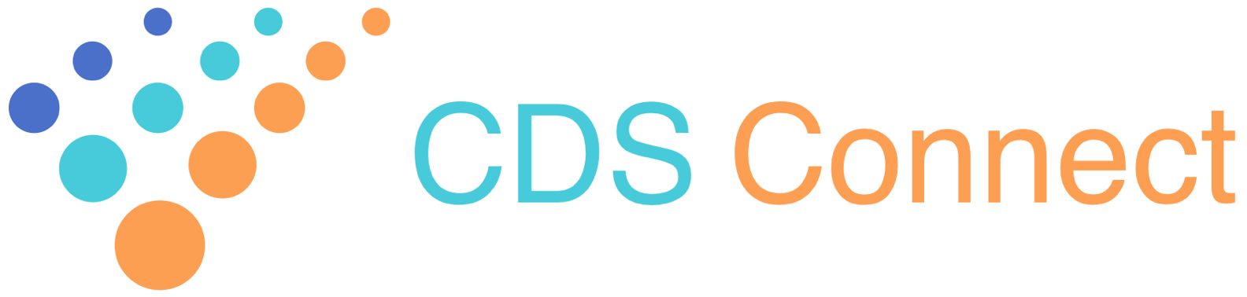
CDS Connect Work Group
Meeting Summary
February 22, 2018
3:00-4:30 PM EST

Attendees
AHRQ Sponsors | Ed Lomotan, Shafa Al-Showk
Work Group Members | Randolph Barrows, Steve Bernstein, Barry Blumenfeld, Edna Boone, Leo Cook, Apurva Desai, Janet Desroche, Vojtech Huser, Preston Lee, Stephen Loueiro, Bob McNellis, Maria Michaels, Jeremy Michel, Ryan Mullins, Dan Pardock, Kavitha Raj, Rachael Roan, Beatriz Rocha, Marc Sainvil, Dave Seltzer, Christopher Shanahan, Danny van Leeuwen, Connie Villalba
MITRE CDS Connect Project Members | Rob McCready, Sharon Sebastian, Julia Afeltra, Noranda Brown, Kevin Hennessey, Sharon Pacchiana, Joey Nichols, Steve Bratt, Chris Moesel, Ginny Meadows, Mike Nosal
The MITRE Corporation operates the Centers for Medicare & Medicaid Services (CMS) Alliance to Modernize Healthcare (CAMH), a federally funded research and development center (FFRDC) dedicated to strengthening the nation’s health care system. MITRE operates CAMH in partnership with CMS and the Department of Health and Human Services.

Agenda
- Welcome and brief review of objectives and agenda
- Update on enhancements to the API to facilitate repository contributions
- Update on Authoring Tool enhancements
- Artifact specifications and contributions discussion
- Repository user experience discussion
- Overview of key takeaways from the CDC CDS Kaizen
- Closing

Meeting Summary

Welcome
MITRE started the meeting welcoming participants and reviewing the names of members participating in the call. Maria Michaels then reviewed the agenda.

Overall:
The meeting included a series of presentations with updates and new enhancements to current services within the CDS repository, Authoring Tool and artifact development efforts. Throughout each presentation it was emphasized that all elements were growing and that continued ideas, suggestions and concerns from the workgroup were welcomed and critical to success.

API to support repository contributions, Kevin Hennessy (MITRE)
Kevin Hennessy (MITRE) provided an overview and update to the repository to support artifact contributions:
- A new Application Programming Interface (API) for CDS Connect artifact authors will allow users with pre-existing CDS artifacts to import them without manually entering data into the artifact authoring web forms, which was previously the requirement. If the data submitted is in the format recognized, the code will populate repository metadata for the contributor’s review. Note: the purpose of this feature is to extract relevant metadata from the artifact; it does not extract and interpret logical constructs.
- Target availability date is mid-March 2018
- Initially this will support artifacts in the FHIRv3.0.1 Clinical Reasoning format with the potential of expansion to other formats.
- Unique identifiers are already built in to the system so each time an artifact is entered, even if it is an update from a previous version, it will have its own unique identifier.
- The Learning Network is addressing issues such as how to address the aging of artifacts and the requirements of authors to update. Currently, as artifacts age, there is a field in the metadata where the author can change it to inactive or retired.

Authoring Tool enhancements, Julia Afeltra (MITRE)

Julia Afeltra (MITRE) provided an overview of some of the enhancements to the Authoring Tool:
- A key feature being updated is “new element”. In the past data elements were pre-defined, such as “LDL Level”. Now there are dropdowns for generic elements (such as medications and observation) and the author can select the specific concept which allows much more flexibility when authoring an artifact.
- Links are provided in the “element” field if authentication with VASC is required to add specific value sets. Once established, the author can select from value sets and edit, as indicated.
- Goals in the future are to enable such functions as being able to add multiple value sets to an element.
- Presenters encouraged participants to please contact them with questions, concerns and/or suggestions to ensure the tool meets their needs.

Artifact specification and contributions, Sharon Sebastian (MITRE)

Sharon Sebastian, the Clinical Lead on the CDS Connect team provided an update about artifact development and value set creation.
  - Artifact for this year:
    - Last year the focus was on artifacts that were based on recommendations. This year the team is working on a unique use case, which is not aligned with one specific recommendation but instead facilitates informed pain management decision making by providing relevant information to the provider.
    - It indirectly supports Centers for Disease Control and Prevention (CDC) recommendation #3 for chronic pain management and opioid prescribing by providing clinical concepts for review and consideration when treating chronic pain.
    - Lookback periods need to be determined. There may need to be some trade-off between processing speed, space available in the user interface, and an ideal lookback period.
    - One participant suggested pulling specific opioid or substance abuse screening scores based on where the patient is in their pain management journey, while leaving out the older (less relevant) information.
  - The work group also discussed how to approach contributions to the repository when the primary source of truth is outside of the repository. The goal of the repository is to be a “one-stop” location to browse for artifacts, however in doing so the supporting data for the artifact may be located elsewhere. The current approach is to populate high-level, informative metadata such as Description, Purpose, Cautions, Source, etc. and then provide web links to the primary source with artifact specifications and code. This is one of several use cases that the Learning Network’s Trust Framework Work Group will be considering over the coming months.

Repository user experience discussion, Mike Nosal and Noranda Brown (MITRE)

Mike Nosal shared new features in the repository and Noranda Brown asked for input on usability:
  - As more classes of artifacts are added to the repository, enhancements will include grouping them into collections of similar Topics, such as those pertaining to immunizations, pain management, those most recently modified, etc. One suggestion was to have a compound search to avoid a lot of individual searches to arrive at the desired artifact.
  - No feedback was provided on the following concepts: Navigation; User Objectives & Actions; Language & Terminology.
  - Concerning Orientation: When searching for specific artifacts, such as those which are semi-structured (i.e., Level 2, L2), the user must find an L2 artifact and click on it to then find others at the same level. A suggestion was made to include a search tool to identify artifacts at specific levels of specification (e.g., L2 artifacts).
  - Concerning Layout: A participant felt it looks good right now. The presenter shared that as more artifacts are added the layout might change. Additional feedback is always welcome.

Takeaways from the CDC CDS Kaizen, Maria Michaels (CDC)

Maria Michaels provided a brief summary of the Kaizen: Adapting Clinical Guidelines for the Digital Age, key areas discussed, along with key take-aways:
- The Kaizen brought together individuals through the continuum of guideline creation – authors, translators, developers, implementers, communicators.
- Key takeaways included
    - It is key to work through the process holistically with all participants involved in creating guidelines from L1 to L4
    - There is uncertainty on how to merge value streams (e.g., where one might start and stop). It is not a linear process
    - Resources and funding are problematic
    - Getting from L2 to L3 is the greatest impediment
    - Ensuring that the L3 artifact contains all the necessary data to be implemented into the local workflow of a user is critical
    - Baseline expectation is that all guidelines will be used electronically and to ensure “down streamers” are involved

